KIRAPIM KAIKAI NA MAKET PROJECT – COMMUNITY DEVELOPMENT WORKERS ASSOCIATION INC.

PROJECT NARRATIVE REPORT – BEGOWO WOMEN in Agriculture

- Activity: Garden, Land and Soil Management Evaluation Report
- Place of interview: SAFANAKA village
- District, LLG, Province: Bena/Goroka, Lower Bena & Goroka LLGs, Eastern Highlands.
- Date of meeting/interview: 24th June 2020
- CDWAI Team: David Kulimbao, Anna Kulimbao and Peter Taul

INTRODUCTION
The CDWAI team (David Kulimbao, Anna Kulimbao, Ben Heyward) taught the BEGOWO women in Agriculture operating from Safanaka village being the central point of training and meeting. The women were taught the different methods of gardening and looking after the land. Some of the new gardening skills the team imparted with field excursions to David/Anna Kulimba’s demonstration backyard gardens include:
- Mulching
- Control Soil erosion
- Compost
- Plant drought resistant crops
- Food processing
- Crop rotation
- Use local insecticide control
- Plant Legume plant/trees
- Contour planting
- Short 3-leaf kaukau vines planting
- A-Frame marking
Eight females from the BEGOWO women in Agriculture were invited to a meeting at Safanaka village. CDWAI team asked the women who attended the meeting: “What do you think of the new ways of gardening system you acquired from the training? Is it of some benefits to you and your garden/land or do you need more training?” Listed are some of the answers from the women:
- Joyce - The training I acquired really changed my ways of gardening but I haven’t had enough time to apply every skill into my gardening system because it is only a few months ago since I acquired the skills. I’m trying my best to apply not all but some of the gardening skills I learned from the training.
- Geraiso - The new method of planting 3-leaf kaukau vines has opened my eyes. My garden is doing well. I’m looking forward to digging big kaukaus soon from every mounds.
- Jennet - I used teprhoesia as insecticide on my potato plots and looking forward to buying some tobacco from the local market to soak in water over night to use on my vegetables/potato garden as well.
- Massi - I planted some teprhoseia seeds along the drains as contour. It is growing. As soon as I get enough dry seeds from these I will plant more contours along the drains. I will try sun flower contour as well.
- Musonimo - We have seen David and Anna Kulimbao’s demonstration garden and are planning to do the same but will take some time to reach their standard. BEGOWO mothers needs more training.

Each one of the women gave a YES or a NO on what they did after the training when interviewed. The women said because of time limitation, they were unable to cover everything but will continue to apply some of the skills acquired whenever applicable.
 | Names of eight women interviewed at Safanaka village
New Garden Methods Application.  (YES / NO) | MASSI PUPUNEFA | MUSONIMO JAMES | MALETO NEHEHA | JENNY JOSEPH | ANNA STEVEN | JOYCE PAUL | GERAISO REX | JENET ONGI
Mulching | YES | YES | YES | YES | YES | YES | YES | YES
Control Soil erosion | YES | YES | NO | YES | YES | YES | YES | YES
Compost | YES | YES | YES | NO | NO | YES | NO | YES
Plant Drought resistant crops | YES | YES | YES | YES | YES | YES | YES | YES
Food processing | YES | YES | NO | NO | NO | NO |  | NO
Crop rotation | YES | YES | YES | YES | YES | YES | YES | YES
Use local insecticide control | NO | YES | NO | YES | YES | NO | YES | YES
Plant Legume plants/trees | YES | YES | NO | NO | NO | YES | YES | NO
Short 3-leaf kaukau vines planting | YES | YES | YES | YES | YES | YES | YES | YES
A-Frame marking | NO | NO | NO | YES | NO | NO | NO | NO
Potato planting | YES | YES | YES | NO | YES | YES | YES | YES
Contour planting | NO | YES | NO | YES | NO | YES | YES | NO

Comments.
After the interview, both groups (cdwai/begowo) agreed that the CDWAI team will do a follow-up on the verbal report to visit some gardens to confirm the application of new methods of gardening as described in the table above. The date to visit five women of Sama villager’s gardens was scheduled to 26th June 2020.

Garden evaluation visit to Sama village in the Goroka District of EHP.

It was Friday 26th June at 8:30am when David Kulimbao and Peter Taul arrived in Sama village to the North of Goroka about five kilometres from Town. Five members of the BEGOWO women were waiting as soon as we stepped out of the Toyota Landcruiser EAH-718. After our welcome and shaking hands with some members of the community for about ten minutes we were led by the women on a walking trip to their gardens.
Mrs Jennet Ongi advised us that because the village was surrounded by coffee plots, villagers walked long distances up into the mountains to cultivate land for gardens. We were asked to get ready for walking. It took approximately one hour, five minutes to come to the first garden. Approximately 2hrs, 10mins walking to and fro after returning to the village.
Refer three of five women photographs below for confirmation of above “yes/no“ table:
NO. | GARDENER | PHOTO 1 | PHOTO 2 | PHOTO 3
1 | 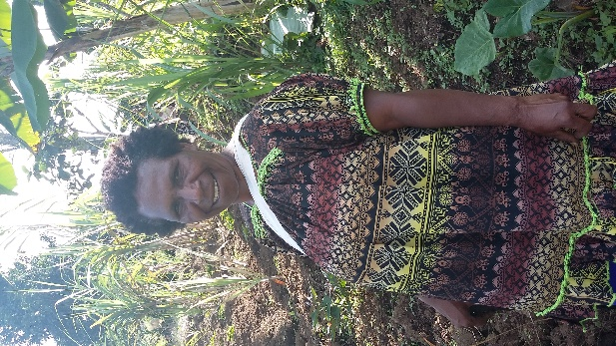  Mrs Joyce Paul – Taro kongkong in background. | 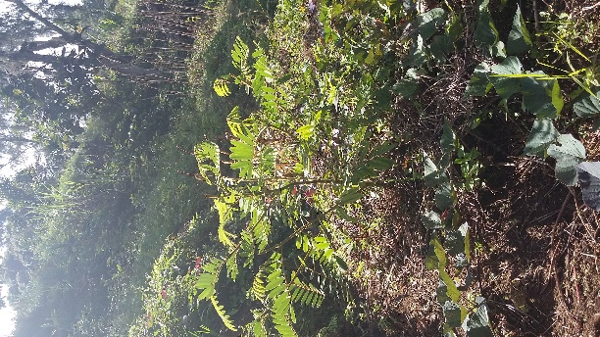  JP - Teprhoseia planted along drain | 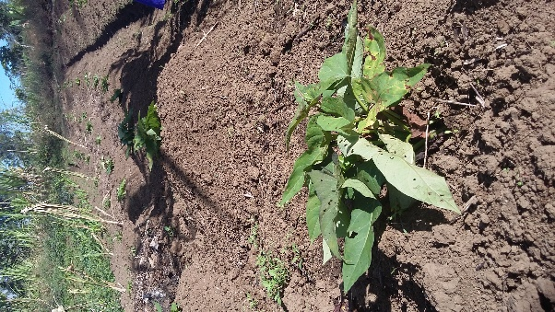  JP - 3-leaf kaukau vine planted | 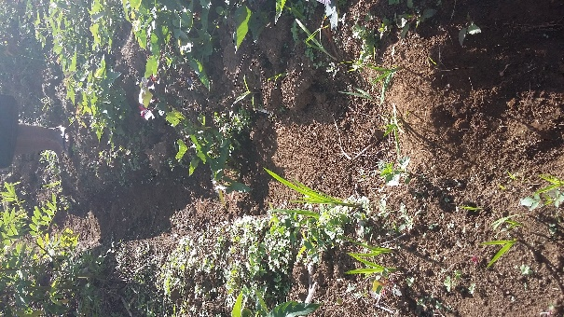  JP - Drain blocked to collect soil erosion
1 | 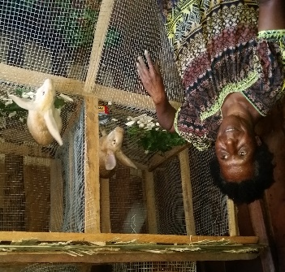  JP – bought two rabbits from potato sales. Will use rabbit’s waste as compost for my gardens. | 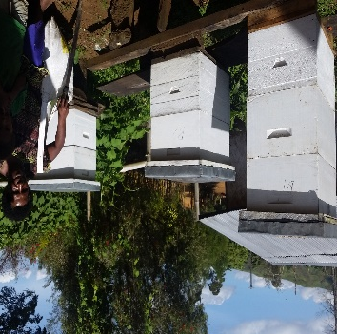  JP – Looking after honey-bees for BEGOWO’s project.
2 | 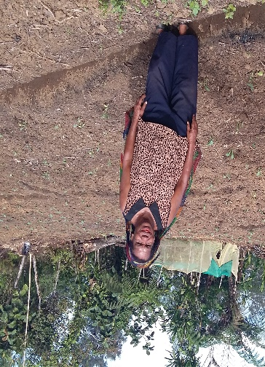  Mrs Jennet Ongi – Capsicum plots. Drains across slope. | 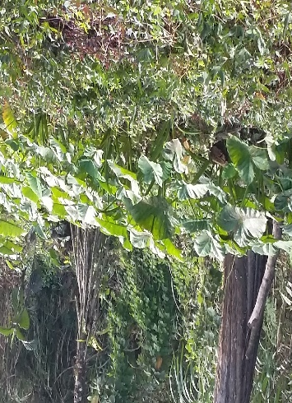  Jo - Drought crop, taro kongkong in JO’s garden | 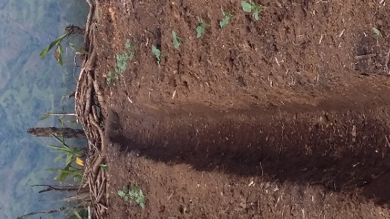  JO - Drain stopped at end to collect eroded soil. | 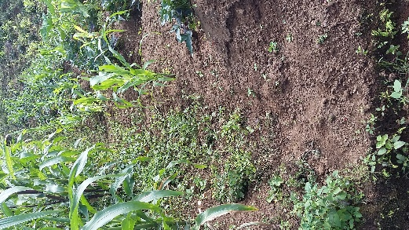  JO - Eroded soil collected at end of drain.
2 | 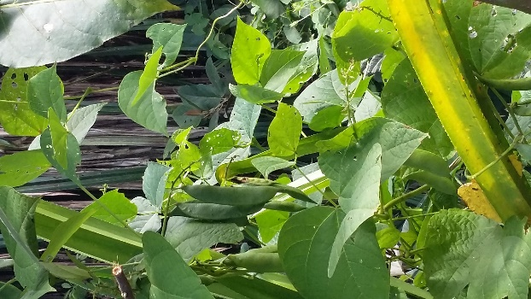  JO - Lima/everlasting bean, drought resistant crop. | 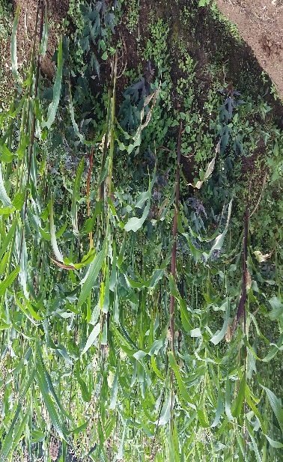  Mixed cropping in Jennet Ongi’s garden. | 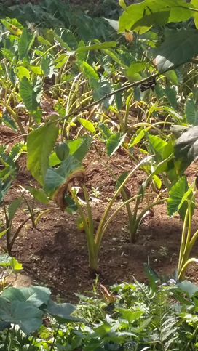  JO – Taro, another drought crop. | 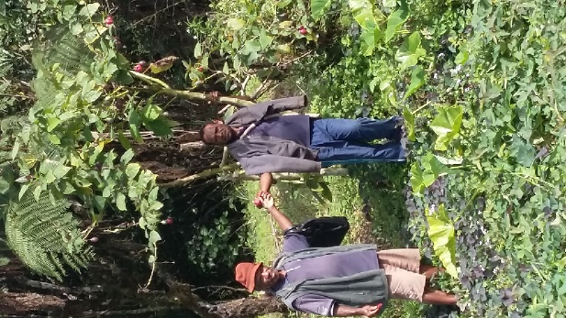  David Kulimbao with guide during the field trip in Jennet’s garden.
2 | Jennet in her potato garden supplied by CDWAI | 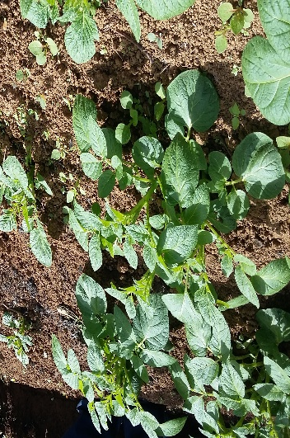  Jennet confirmed using teproseia on the potato as local insecticide. She plans to use tobacco as well. | 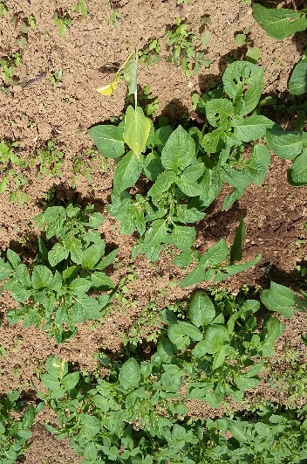  JO-Planted in a zig-zag manner to compare yield with next photo planted in straight line. | 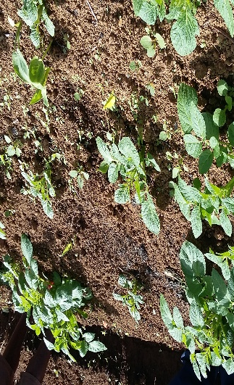  JO – planted in straight line to compare yield to the zig-zag style opposite.
2 | 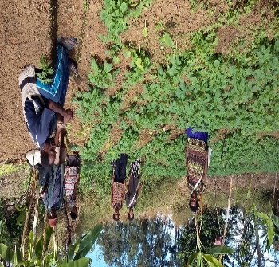  Field trip team in Jennet’s garden.
3 | 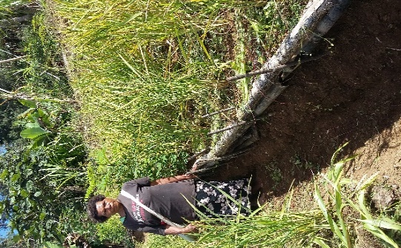  Mrs Geraiso Rex in her rice plots. Drought storage crop. | 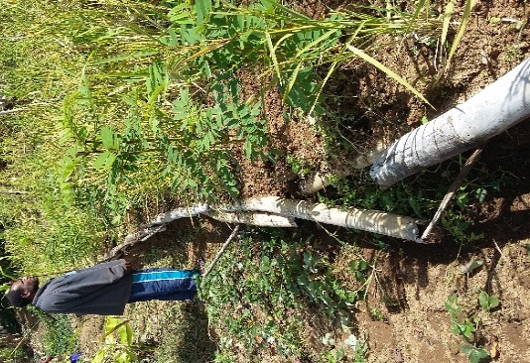  GR – Rice on sloppy plots. Blocked soil from eroding. | 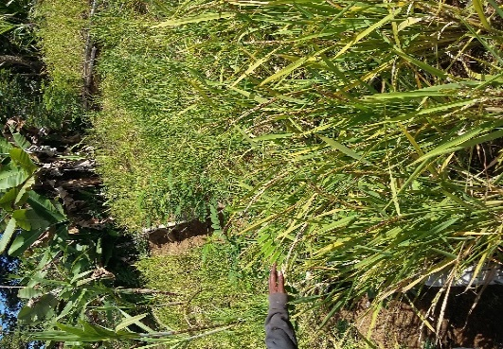  GR – Teproseia planted along drain as nursey for seeds for future use. Plant will control erosion, as legume and when cut and placed in garden as mulch and compost as well as using the leaves as local insecticide. | 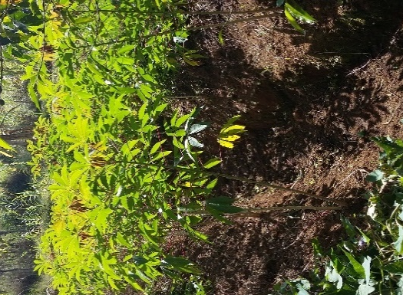  GR – Witnessed cassava as well as taro kongkong in Geraiso’s garden as drought crops.
3 | 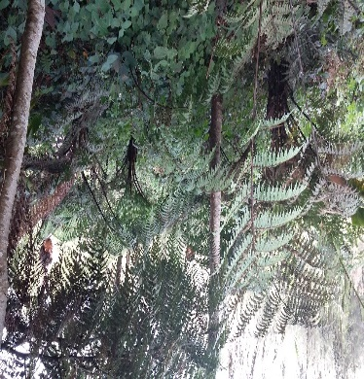  GR – Planted a garden of bush ferns in preparation of a drought. | 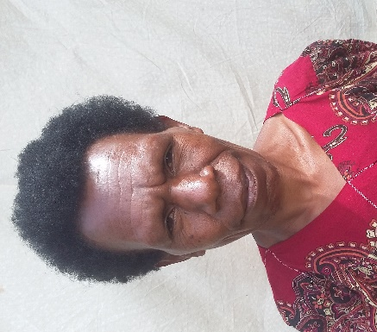  - Mrs JENNY JOSEPH – unable to visit her Sama garden because of the distance. | 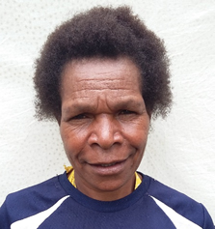  - Mrs SITA KOLE - unable to visit her Sama garden because of the distance. | 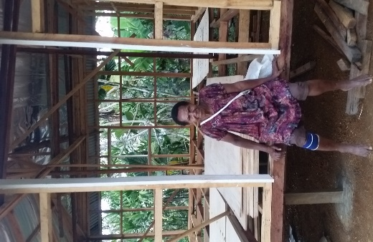  Mrs HAHIE GANE bought some iron sheets from potato sales for her new house.

Unfortunately, David and Peter did not manage to visit Jenny Joseph and Sita Koles’ gardens because the women were pointing to a tallest tree in the mountain which we estimate to be about 30mins walking distance. Culturally, as we know when these women say the tallest tree, they actually mean another 30mins walk from there to the next tallest tree or a shorn cliff limestone or whatever the landmark maybe…… Anyway, we appreciated and thanked the women but decided to return back to the village because David had flu which might be the much talked about thing or whatever, while Peter’s knees were not keeping to the natural course but began to wobble.
( Below are photographs of interest)
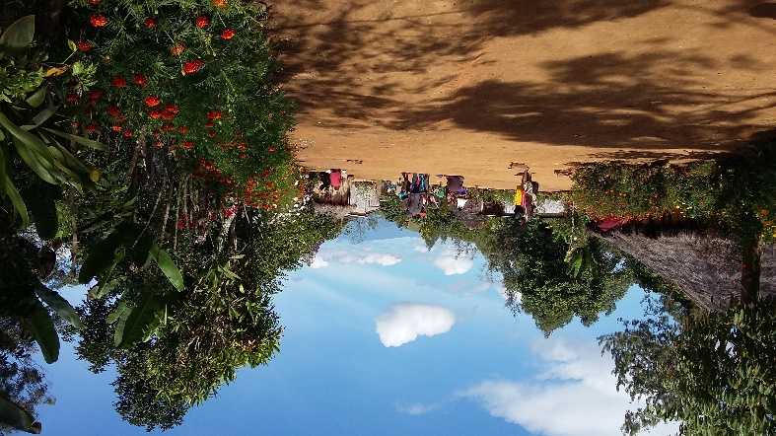  SAMA village is located five kilometers to the North of Goroka Township. | GOROKA Town in the background looking down from Jennet’s mountain garden.
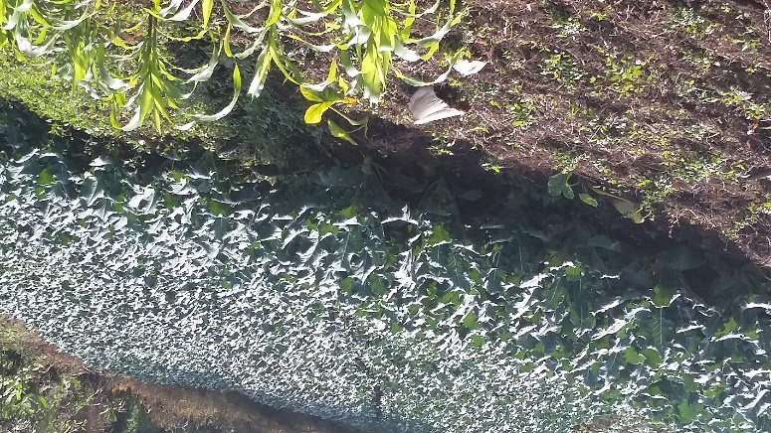  Capsicum plots of someone in the Sama mountains. | 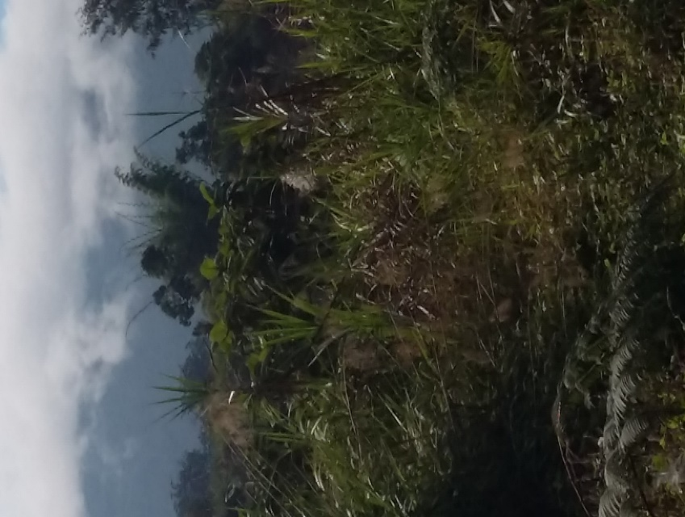  The plane crash site (Sama) where Mr Danny Leahy (explorer) had his lips cut when he was a small boy. Part of the crashed plane can be seen from here.

End of report

